Activity: Tracking the Dekalb County Tornado

Introduction

“A powerful storm system roared across the southeastern United States on Wednesday, April 27, 2011. This storm system spawned 39 tornadoes in the Huntsville forecast area and a total of 62 tornadoes which impacted locations in the state of Alabama. This system also produced extensive flash flooding, large hail, and straight lined wind damage as well. However, this event will always be remembered as a tragic tornado event which produced more strong (EF2-EF3) to violent (EF4-EF5) tornadoes than the historic 1974 tornado outbreak.”

“In the wake of this system, hundreds of people were left injured and/or homeless, along with approximately 100 people who lost their lives in the northern Alabama area alone. Across the state of Alabama, 272 people lost their lives and at least 1969 (almost 2,000 people!) were injured. Some of the devastation was literally unimaginable with countless homes, neighborhoods and even portions of cities or towns either partially or completely destroyed. This storm system would be responsible for one of the largest and deadliest tornado outbreaks to ever impact much of the southeastern region.” [NWS Huntsville (http://www.srh.noaa.gov/hun/?n=hunsur_2011-04-27_main)]

That day was one of the most damaging and deadly days in U.S. tornado history. The NWS’ Storm Prediction Center recorded 292 tornado reports along with other thunderstorm hazards such as 438 instances of damaging winds and 207 cases of hail damage. One storm in the northern Alabama area spawned an EF-5 which devastated the communities of Shiloh, Rainsville, Henagar, and part of Sylvania in Dekalb County. There were 23 fatalities in Dekalb County alone. For more information of the Enhanced Fujita scale for tornado damage and the relation to wind speeds, see: http://www.spc.noaa.gov/faq/tornado/ef-scale.html.

Tornadoes are dangerous storms. This activity will demonstrate some of the characteristics of severe tornadoes and appropriate preparedness and response actions you should make when the threat of tornadoes occurs.

The following map shows tracks of tornadoes that passed through the area of responsibility of the NWS Huntsville Forecast Office shaded in beige on April 27, 2011. The damage produced by the storms is shown according to the Enhanced Fujita scale (EF) according to the color coding below the map. The Dekalb County tornado track is seen in the right center of the map area.

©American Meteorological Society

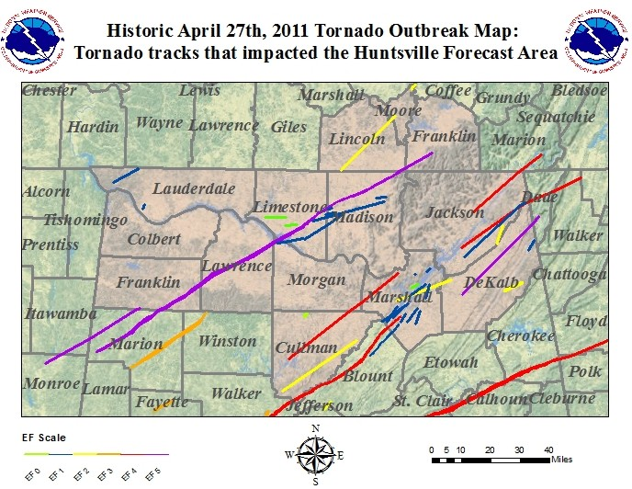

Activity
After completing this exercise, you should be able to:

- describe the motion of a severe tornado, including the width of its path, average speed and direction.

- list appropriate actions to take to save lives when tornadoes threaten, including those that address the special threats of mobile-home living.

The detailed accompanying map of the Dekalb County tornado track (next page) shows the path of tornado damage while on the ground. The shading indicates estimated Enhanced Fujita intensities based on the damage that occurred. Some of the statistics determined by the NWS damage survey following the storm were:

Rating | EF – 5 | Peak Wind | > 200 mph
Path Length | 33.66 miles | Max. Path Width | 0.75 miles
Starting Point | 34.39 N, 85.98 W | Ending Point | 34.73 N, 85.56 W
Starting Time | 6:19 PM CDT | Ending Time | 6:56 PM CDT

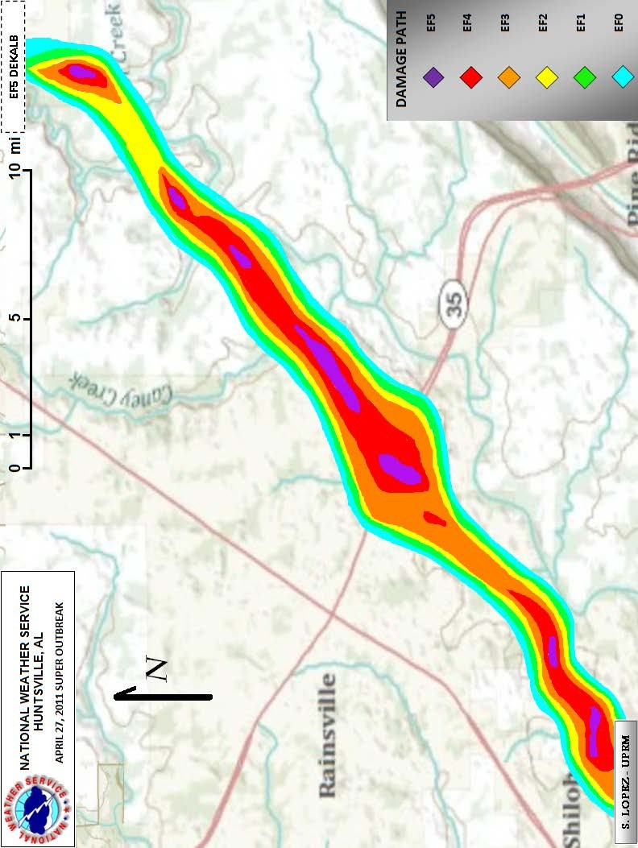

Answer the following questions based on the table and map information.

- For how long a time period was the tornado on the ground?

- Towards what general direction (southeast, southwest, northwest, northeast) did the tornado move?

- What was the length of the tornado path?

- What was the average ground speed of the tornado?

- The purple shading indicates where damage was rated EF-5, the most severe for this tornado. At how many points along the track was this level of damage found?

- Based on the table information provided, which of the following was most likely the maximum width of the tornado --- 40 feet, 400 feet, 4,000 feet, 4 miles? (One mile is 5,280 feet.)

- The very deadly year, 2011, had 550 fatalities recorded. Of those, 112 or 20% occurred in mobile homes. Mobile homes, also often called manufactured housing, comprise only 8% of all home structures. These deaths occurred despite typically 10 or more minutes of warning lead time nationally and frequent media reporting with wide availability of personal communications devices. What are some of the special dangers of mobile home living?

- Use safety rules and information provided by the National Weather Service or the American Red Cross to determine where you should take shelter when a tornado threatens. What special precautions should mobile home parks and residents take to reduce severe weather threats?

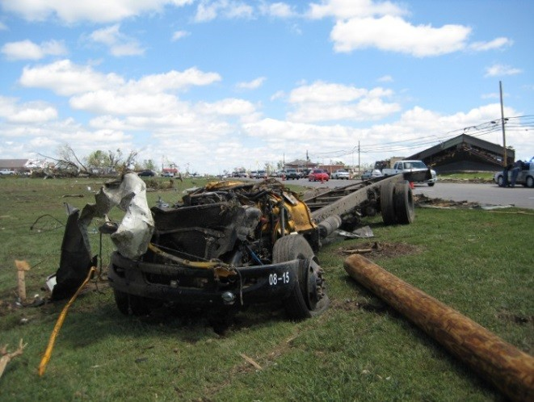
Some photographs from the Dekalb County tornado destruction testify to the power of these severe storms. [http://www.srh.noaa.gov/hun/?n=4272011_dekalb_county]

The remains of a school bus that was blown across Hwy 75 in Rainsville. This bus was originally sitting in the parking lot adjacent to the building in the distance to the right.

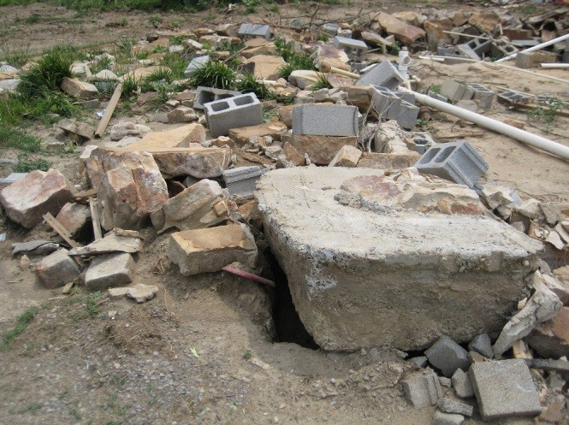
View of the remains of a stone-built home on Skaggs Rd. Notice the large piece of concrete foundation that was pulled out of the ground.

